A MAJOR PROJECT

OF

**Department Of Electrical Engineering**

Session (2019-2022)

**ARDUINO BASED CAR PARKING SYSTEM**

**SUBMITTED TO: -**  **SUBMITTED BY: -**

MS. Garima Agarwal (HOD) 1.Prashant Yadav (190260900058)

Praveen Dabur (Mentor) 2.Prince Nayan (190260900059)

3.Shashi Shankar (190260900085)

4.Rajan Singh (190260900064)

5.Vipin Kumar (190260900105)

**Acknowledgement**

We want to thank GOD for giving us the ability to complete our research.

We want to express our deepest gratitude and appreciation to our mentor Mr. Pravin Dabur for his continuous effort to guide us through our PROJECT.

We want to thank C.M.R.A GOVT. POLYTECHNIC SANGHI for giving us the Right environment to complete our study.

Special thanks to our families and our friends for their unconditional love and support for us.

# CONTENTS

* **CONTENT**
* **INTRODUCTION**
* **SMART PARKING SYSTEM**
* **ADVANTAGE OF SMART SMART PARKING SYSTEM IMPLEMENTION**
* **AIM AND WORK**
* **ARDUINO UNO R3**
* **20X4 LCD DISPLAY**
* **I2C LCD MODULE**
* **MINI SERVO MOTOR SG90**
* **IR SENSOR MODULE**
* **JUMPER WIRE**
* **FEMALE DC POWER JACK**
* **DC LED BULB**
* **SWITCH BUTTON**
* **LIGHTING ARRESTOR**
* **LED INDICATOR**
* **SCHEMATIC DIAGRAM**
* **IMPLEMENTED PROJECT WORK**
* **CONCLUSION**

**INTRODUCTION**

There are two types of parking management system first is a normal parking system and another one is an automatic parking system. What we are using nowadays to park the vehicle is normal parking system.In normal parking system, problem faced by people due to lack to car parking management is shown in Fig.1 An automatic parking system is used to make the whole process of car parking more efficient and less complex for both drivers and supervisor. This can be done through sensors, microcontroller, LEDs as indicator, LCD display and servo-motor. By storing the data related to parking area in cloud can be accessed from anywhere. To access the data from cloud internet is required.

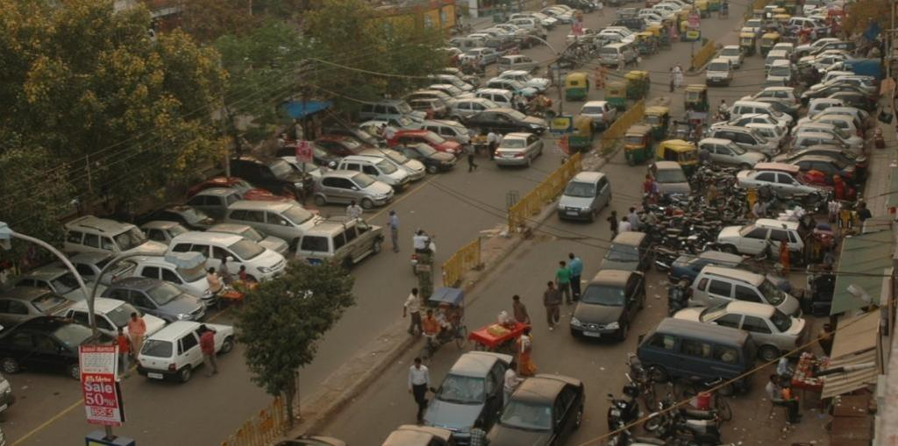 Fig.1 **Improper Parking**

* **Smart Car Parking System**
* Smart Parking is a parking strategy that combines technology and human innovation in an effort to use as few resources as possible—such as fuel, time and space—to achieve faster, easier and denser parking of vehicles for the majority of time they remain idle.
* Thanks to digitalization, smart parking systems are starting to offer **solutions for urban mobility.** This is a system which, thanks to the Internet of Things and sensor technology, allows real-time data to be obtained about parking availability, both [outside](https://tomorrow.city/a/outdoor-smart-parking-solutions-parking-made-simple) and inside, and regarding traffic and road conditions.

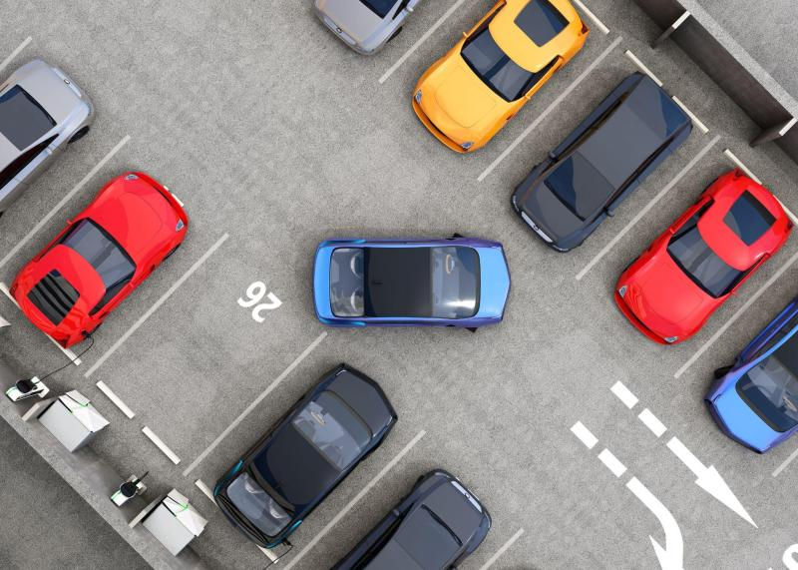

* **ADVANTAGE OF SMART SMART PARKING SYSTEM IMPLEMENTION**

• Accurately predict and sense spot/vehicle occupancy in real-time.

• Guides residents and visitors to available parking.

• Optimize Parking Space Usage

• Simplifies the parking experience and adds value for parking stakeholders, such as drivers and merchants

• Help traffic in the city flow more freely leveraging IoT technology.

• Enables intelligent decisions using data, including real–time status applications and historical analytics reports

• Smart Parking plays a major role in creating better urban environment by reducing the emission of CO2 and other pollutants

• Smart Parking enables better and real time monitoring and managing of available parking space , resulting in significant revenue generation

• Provides tools to optimize workforce management

* **AIM AND WORK**

The purpose of the project is to reduce the number of workers in the garage and reduce the prevalence of owners of cars because there is in the 6-meter counter at the entry of the car has a count down. While, when the exit is counting ascending or according to what is mentioned or written within the programming of Arduino and determine the absorption of the garage number of vehicles through the owner.

When the highest value of the meter, the door of the garage is closed electronically and cannot be opened until the exit of one of the cars and this project can be added by several devices that help the person to gain time and reduce the congestion caused by protrusion such as the depletion of the GPS.

* **THEORY OF PROJECT**
* **ARDUINO UNO R3**
* The **Arduino Uno** is an [open-source](https://en.wikipedia.org/wiki/Open-source) [microcontroller board](https://en.wikipedia.org/wiki/Microcontroller_board) based on the [Microchip](https://en.wikipedia.org/wiki/Microchip_Technology) [ATmega328P](https://en.wikipedia.org/wiki/ATmega328P) microcontroller and developed by [Arduino.cc](https://en.wikipedia.org/wiki/Arduino). The board is equipped with sets of digital and analog [input/output](https://en.wikipedia.org/wiki/Input/output) (I/O) pins that may be interfaced to various [expansion boards](https://en.wikipedia.org/wiki/Expansion_board) (shields) and other circuits. The board has 14 digital I/O pins (six capable of [PWM](https://en.wikipedia.org/wiki/Pulse-width_modulation) output), 6 analog I/O pins, and is programmable with the [Arduino IDE](https://en.wikipedia.org/wiki/Arduino#Software) (Integrated Development Environment), via a type B [USB cable](https://en.wikipedia.org/wiki/USB_cable). It can be powered by the USB cable or by an external [9-volt battery](https://en.wikipedia.org/wiki/9-volt_battery), though it accepts voltages between 7 and 20 volts. It is similar to the [Arduino Nano](https://en.wikipedia.org/wiki/Arduino_Nano) and Leonardo. The hardware reference design is distributed under a [Creative Commons](https://en.wikipedia.org/wiki/Creative_Commons) Attribution Share-Alike 2.5 license and is available on the Arduino website. Layout and production files for some versions of the hardware are also available.
* The word "[uno](https://en.wiktionary.org/wiki/uno)" means "one" in [Italian](https://en.wikipedia.org/wiki/Italian_language) and was chosen to mark the initial release of [Arduino Software](https://en.wikipedia.org/wiki/Arduino_Software). The Uno board is the first in a series of USB-based Arduino boards; it and version 1.0 of the Arduino [IDE](https://en.wikipedia.org/wiki/Integrated_development_environment) were the reference versions of Arduino, which have now evolved to newer releases. The ATmega328 on the board comes preprogrammed with a [bootloader](https://en.wikipedia.org/wiki/Bootloader) that allows uploading new code to it without the use of an external hardware programmer.
* While the Uno communicates using the original STK500 protocol, it differs from all preceding boards in that it does not use the FTDI USB-to-serial driver chip. Instead, it uses the Atmega16U2 (Atmega8U2 up to version R2) programmed as a [USB-to-serial converter](https://en.wikipedia.org/wiki/USB-to-serial_converter).

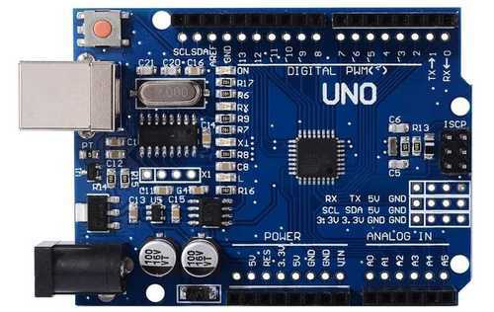

* Advantages of Arduino:
* **Simplicity**

Arduino's paintings are designed to suit the needs of all engineers, designers, professors, students, and interactive

electronics enthusiasts around the world.

* **The price**

The Arduino Plate is less expensive than any competitor of the same type. The most expensive painting is not more than $ 50.

* **Self-Assembly**

Easy to deal with and easy to connect circuits, as we mentioned in our first article that it was an easy solution to the

problem of microcontrollers and complex connections.

* **Multi-platform**

The Arduino program has the ability to work with all the different operating systems of Windows, Mac and Linux, while most other boards running on Windows only

* **Easy and simple software environment**

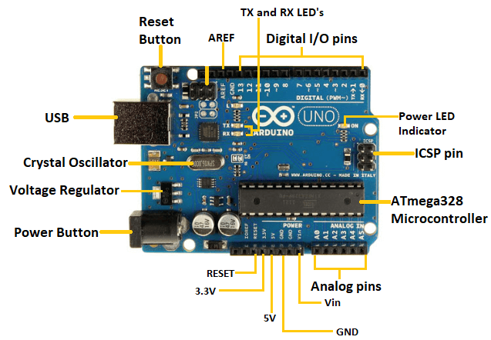 The "Environment" programming environment is designed to be easy for beginners and powerful professionals and its programming language "Arduino C" is easy to learn

* **20X4 LCD DISPLAY**
* 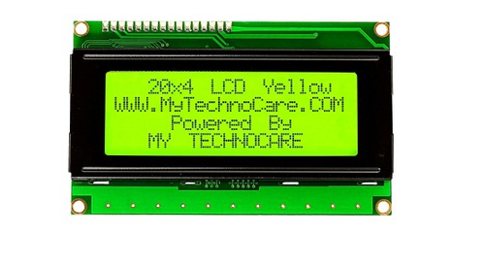The LCD stands for liquid crystal display, that works on the light modulation features of liquid crystals. It is available in electronic visible display, video display and flat panel display. There are numerous categories and features are exits in markets of LCD and you can see it on your mobile, laptop, computer and television screen. The invention of LCD gives new life to electronic industries and replaces lED and gas plasma techniques. It also replaces the CTR (cathode ray) tube that used for visual display. The input power consumed by the liquid crystal display is less then light-emitting diode and plasma display. In today's post, we will have look at 20 x 4 LCD, its features, working, applications, and practical implementation in different electronic devices.So let's get started with the Introduction to 20x4 Module LCD.

**Fig:**20x4LCD Display

* **I2C LCD MODULE**
* **It uses only 2 bi-directional open-drain lines for data communication called SDA and SCL**. Both these lines are pulled high. Serial Data (SDA) – Transfer of data takes place through this pin. Serial Clock (SCL) – It carries the clock signal.

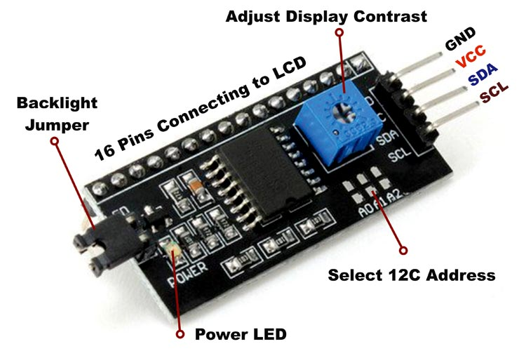

**Fig :i2c Module**

* **The Servo Motor**
* The servo engine is a motor that comes with a Gear gearbox and a Shaft transmission that gives motion greater torque and greater precision. This engine can rotate 180 degrees and in some types 360 degrees.
* The servomotor is internally made up of a "mostly microcontroller" control circuit. When the engine gives pulses at a certain time constant, the engine rotates to the angle according to that time constant.
* In each type, the time constant varies from one engine to another according to the manufacturer and the technical bullet in that comes with the servo engine.
* In the Arduino, programming environment there is a library called Servo Library installed in the program. This library gives us the ability to control most of the 180degree Cervo drives. At the end of this post, you will have the ability to use the library's commands through practical examples.

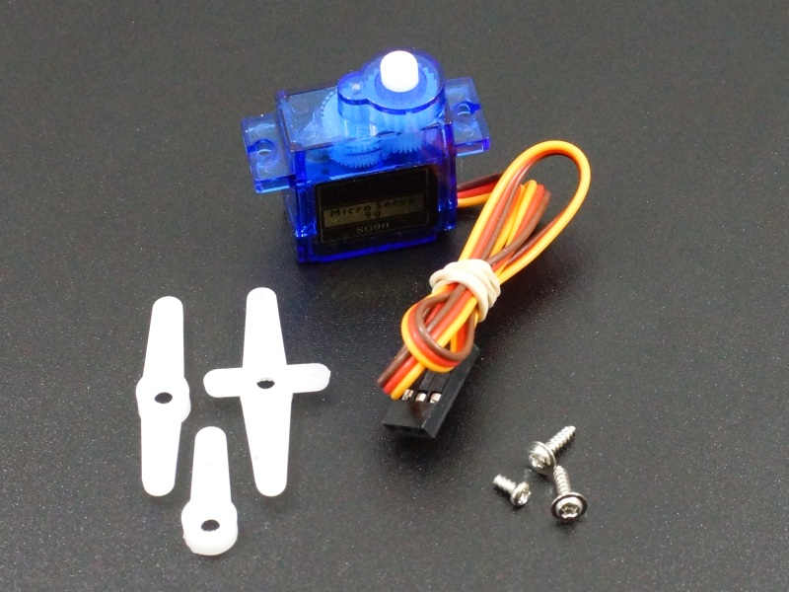

**Fig:** Mini Servo Motor

* **IR SENSOR MODULE**

## **Introduction**

The IR Sensor Module or infrared (IR) sensor is a basic and most popular sensor in electronics. It is used in wireless technology like remote controlling functions and detection of surrounding objects/ obstacles. IR sensors mainly consist of an Infrared(IR) LED and a Photodiode, this pair is generally called IR pair. An IR LED is a special purpose LED, it is can emitting infrared rays ranging from 700 nm to 1 mm wavelength. These types of rays are invisible to our eyes. In contrast, a photodiode or IR Receiver LED detects the infrared rays.

## IR Sensor Module - Chawla Electronic**How IR Sensor Module Works**

When we connect the IR sensor module to 5v power supply. At the same time, Infrared LED (IR-TX) starts emitting infrared rays. Then set the threshold voltage at the Non-Inverting input (3) of the IC by rotating the potentiometer knob for setting the sensor sensitivity.

If infrared rays reach to object’s surface and some of the radiation reflected back to the IR receiver (IR-RX). The Photodiode or IR receiver (IR-RX) detects the infrared light.

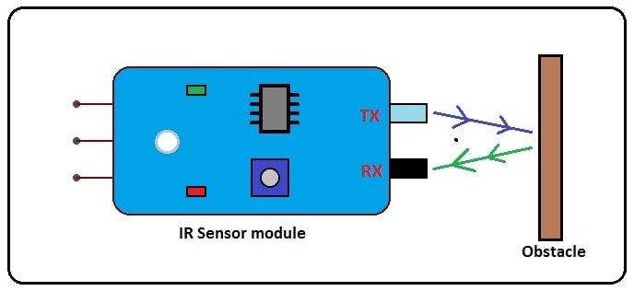

When reflected infrared light Falls on the Photodiode, the resistance of the photodiode falls down from a huge value and the voltage across the photodiode drops. So, a **High** amount of voltage from the photodiode is given to the **Inverting input (2)** of the IC. Then the LM393/LM358 IC compares this voltage with the threshold voltage. In this condition, the Inverting input voltage is **greater than** the Non-Inverting input voltage so the IC output is **Low (0)**. So, the **sensor output is Low (0)**.

When the Photodiode or IR receiver (IR-RX) **does not detect** the infrared light, then the resistance of the photodiode will very high. So, a **Low** amount of voltage from the photodiode is given to the **Inverting input (2)** of the IC. Then the LM393/LM358 IC compares this voltage with the threshold voltage. In this condition, the Inverting input voltage is **less than** the Non-Inverting input voltage so the IC output is **High (1)**. So, the **sensor output is High (1)**.

* **JUMPER WIRE**

Jumper wires are extremely handy components to have on hand, especially when prototyping. But what are they?

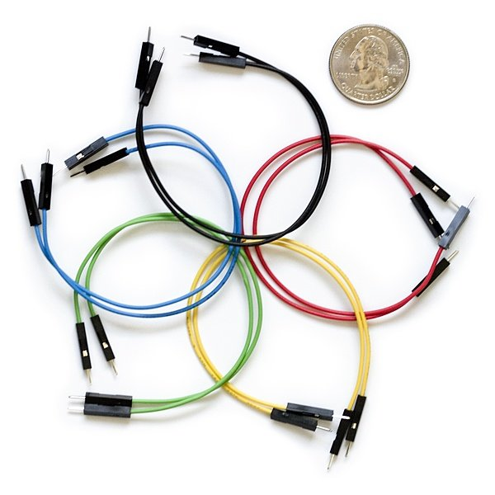

Jumper wires are simply wires that have connector pins at each end, allowing them to be used to connect two points to each other without soldering. Jumper wires are typically used with [breadboards](https://blog.sparkfuneducation.com/what-is-a-breadboard) and other prototyping tools in order to make it easy to change a circuit as needed. Fairly simple. In fact, it doesn’t get much more basic than jumper wires.

## jumper wire colors**What Do the Colors Mean?**

Though jumper wires come in a variety of colors, the colors don’t actually mean anything. This means that a red jumper wire is technically the same as a black one. But the colors can be used to your advantage in order to differentiate between types of connections, such as ground or power.

## **Make Your Own Jumper Wires**

While jumper wires are easy and inexpensive to purchase, it can also be a fun task to [challenge students to make their own](http://www.dummies.com/programming/electronics/how-to-make-jumper-wires/). Doing so requires insulated wire and wire strippers. However, beware that it is important not to nick the wire when stripping off the insulation.

## **Types of Jumper Wires**

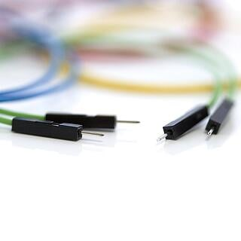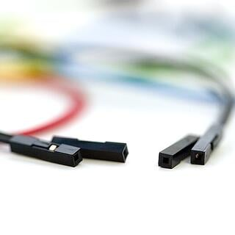

Jumper wires typically come in three versions: male-to-male, male-to-female and female-to-female. The difference between each is in the end point of the wire. Male ends have a pin protruding and can plug into things, while female ends do not and are used to plug things into. Male-to-male jumper wires are the most common and what you likely will use most often. When connecting two ports on a breadboard, a male-to-male wire is what you’ll need.

* **FEMALE DC POWER JACK**
* This is DC Power Jack Female Connector with 2 pin Screw Terminal - 2.1 x 5.5mm Connector Plug For CCTV Camera. Simple & Professional appearance for power cabling. Easier for camera installation saves time and assures secure cable connection.No electrical tap, No splicing, no crimping, but only a small screwdriver.

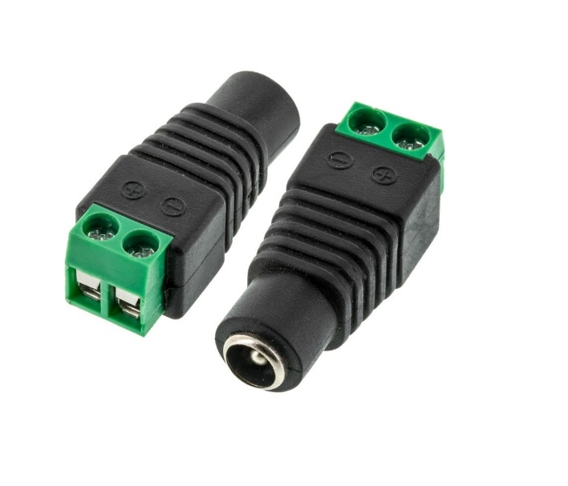

* **DC LED BULB**
* The simplest circuit to drive an LED is through a series resistor. It is commonly used for indicators and digital displays in many consumer appliances. However, this circuit is not energy-efficient, because energy is dissipated in the resistor as heat.

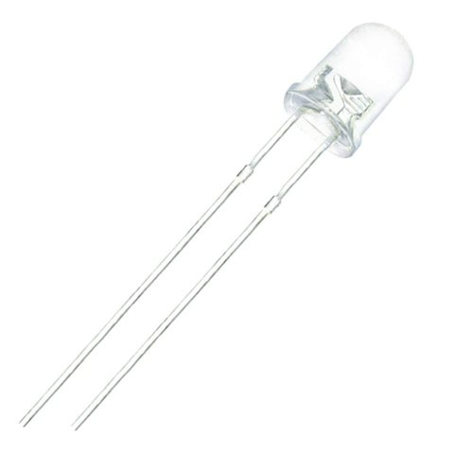

* **SWITCH BUTTON**
* A **switch button**  is an [electrical component](https://en.wikipedia.org/wiki/Electrical_component) that can disconnect or connect the conducting path in an [electrical circuit](https://en.wikipedia.org/wiki/Electrical_circuit), interrupting the [electric current](https://en.wikipedia.org/wiki/Electric_current) or diverting it from one conductor to another.
* **LIGHTING ARRESTOR**
* A **lightning arrester** is a device used on [electric power transmission](https://en.wikipedia.org/wiki/Electric_power_transmission) and [telecommunication](https://en.wikipedia.org/wiki/Telecommunication) systems to protect the [insulation](https://en.wikipedia.org/wiki/Insulator_(electrical)) and [conductors](https://en.wikipedia.org/wiki/Electrical_conductor) of the system from the damaging effects of [lightning](https://en.wikipedia.org/wiki/Lightning). The typical lightning arrester has a [high-voltage](https://en.wikipedia.org/wiki/High_voltage) terminal and a [ground](https://en.wikipedia.org/wiki/Ground_(electricity)) terminal. When a lightning surge (or switching surge, which is very similar) travels along the [power line](https://en.wikipedia.org/wiki/Power_line) to the arrester, the [current](https://en.wikipedia.org/wiki/Electric_current) from the surge is diverted through the arrester, in most cases to earth.

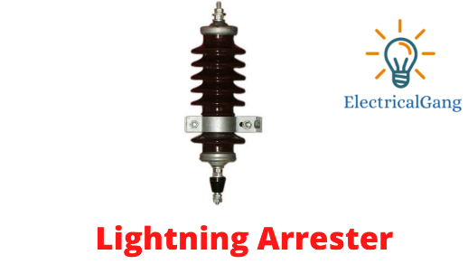

* **LED INDICATOR**
* 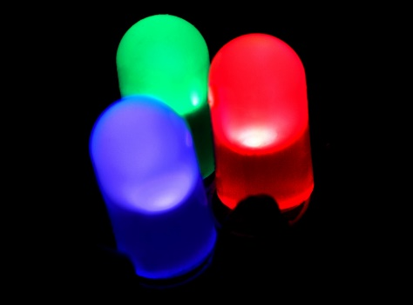Indicator lights are **a type of illuminating device that is commonly used to signify that equipment is either receiving power or that there is some form of malfunction**. We have all seen the red light come on when you power on a device. That is an example of an indicator light.
* **SCHEMATIC DIAGRAM**

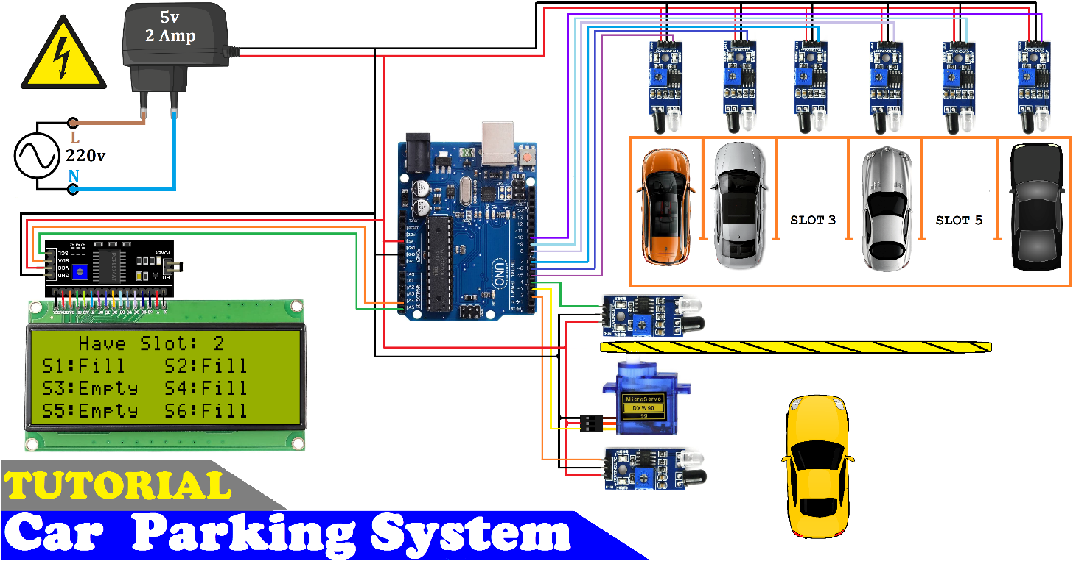

* **IMPLEMENTED PROJECT WORK**

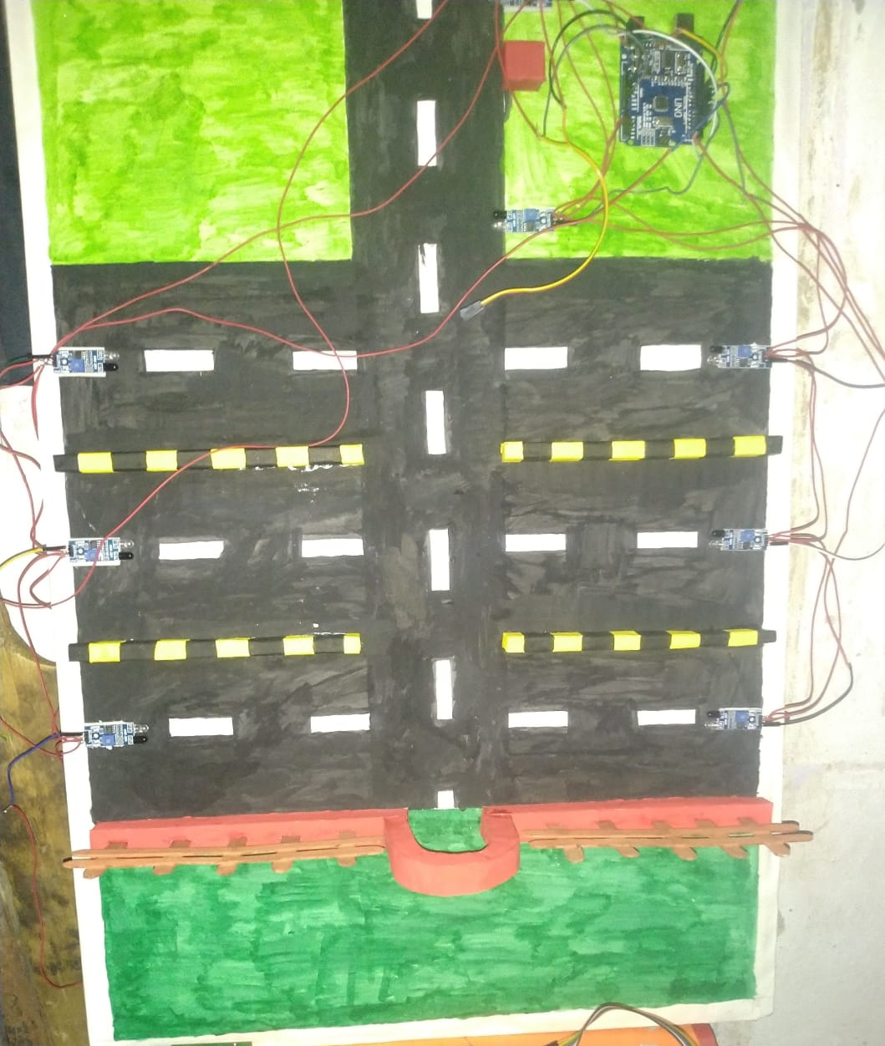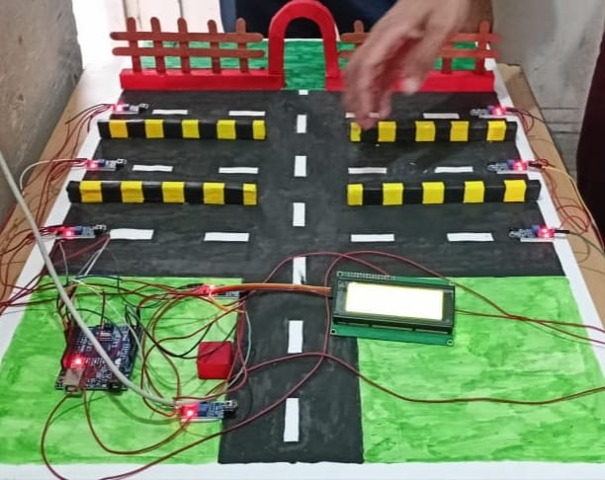

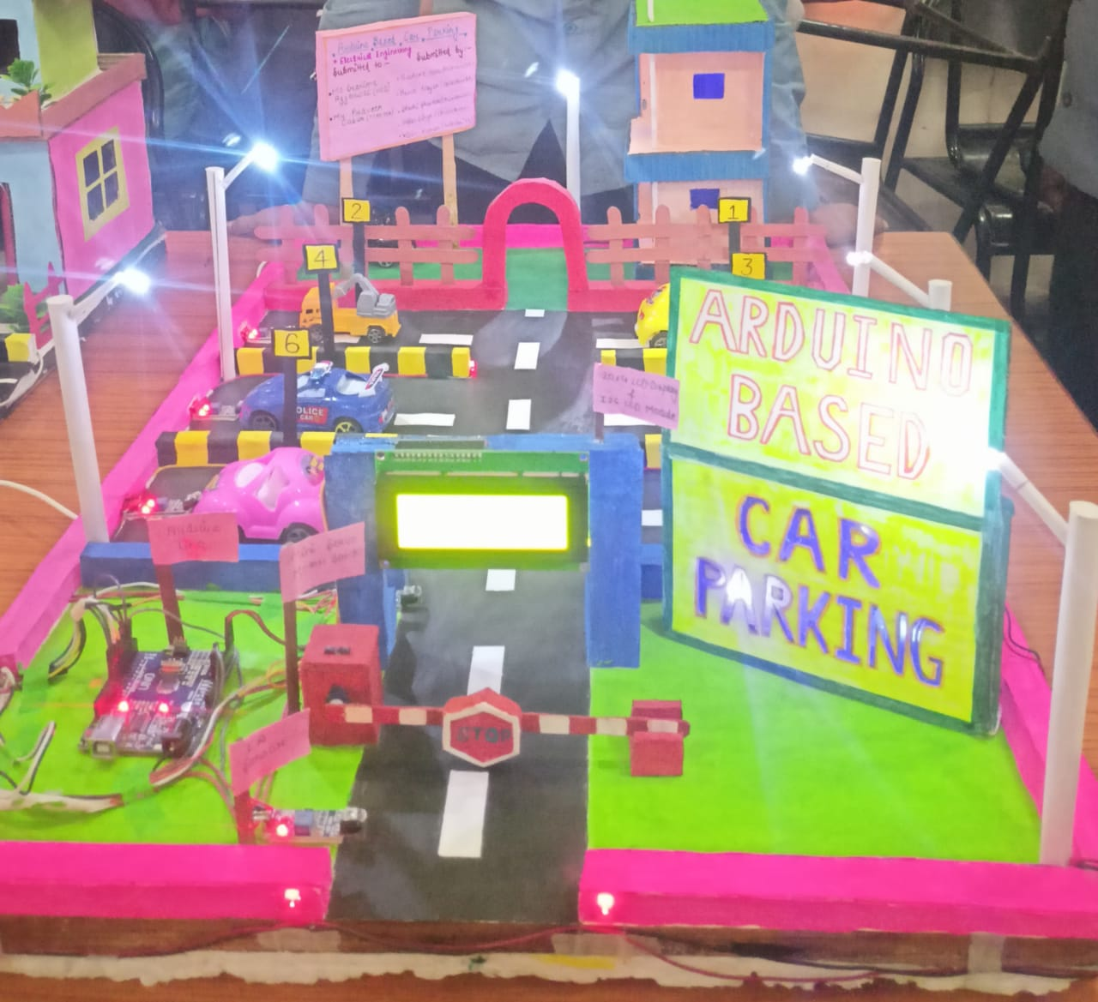

* **CONCLUSION**
* In this study, the various types of smart parking system and has been presented. From the various examples of the implementation of the smart parking system being presented, its efficiency in alleviating the traffic problem that arises especially in the city area where traffic congestion and the insufficient parking spaces are undeniable. It does so by directing patrons and optimizing the use of parking spaces.
* With the study on all the sensor technologies used in detecting vehicles, which are one of the most crucial parts of the smart parking system, the pros and cons of each sensor technologies can be analysed. Although, there are certain disadvantages in the implementation of visual based system in vehicle detection as described earlier, the advantages far outweighs its disadvantages.

**THANK YOU**